The Course Project

The course project consists of four parts. Parts 1, 2, 3 require the use of the project data zip file, while part 4 requires the use of a text file generated from part 3.

**Part 1:**

The first part is to develop a Mapper and Reducer application to calculate the ***median***of *wind direction* (degree) for *each observation month* *from each year* (e.g. 195001) from NCDC records (note: 999 indicates missing value, and [01459] indicate good quality value).

**Used JAVA to develop the Mapper and Reducer applications: the three java files**

* WindDirection.java
* WindDirectionMapper.java
* WindDirectionReducer.java

**Compile java file**:

javac -cp hadoop-common-2.6.1.jar:hadoop-mapreduce-client-core-2.6.1.jar:commons-cli-2.0.jar -d . WindDirection.java WindDirectionMapper.java WindDirectionReducer.java

**Create the jar file**

jar cvf WindDirection.jar WindDirection*.class

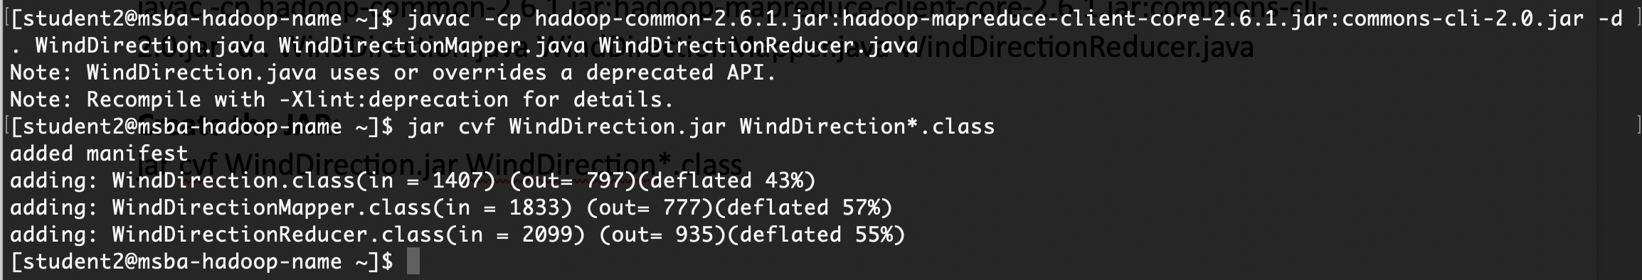

**Create an Input directory:**

hdfs dfs -mkdir /home/2student2/projectinput

**Copy file from Local Disk to HDFS:**

hdfs dfs -copyFromLocal Project_Data/*.gz /home/2student2/projectinput/

**Run a Jar file:**

hadoop jar WindDirection.jar WindDirection /home/2student2/projectinput /home/2student2/projectoutput

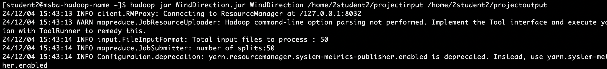

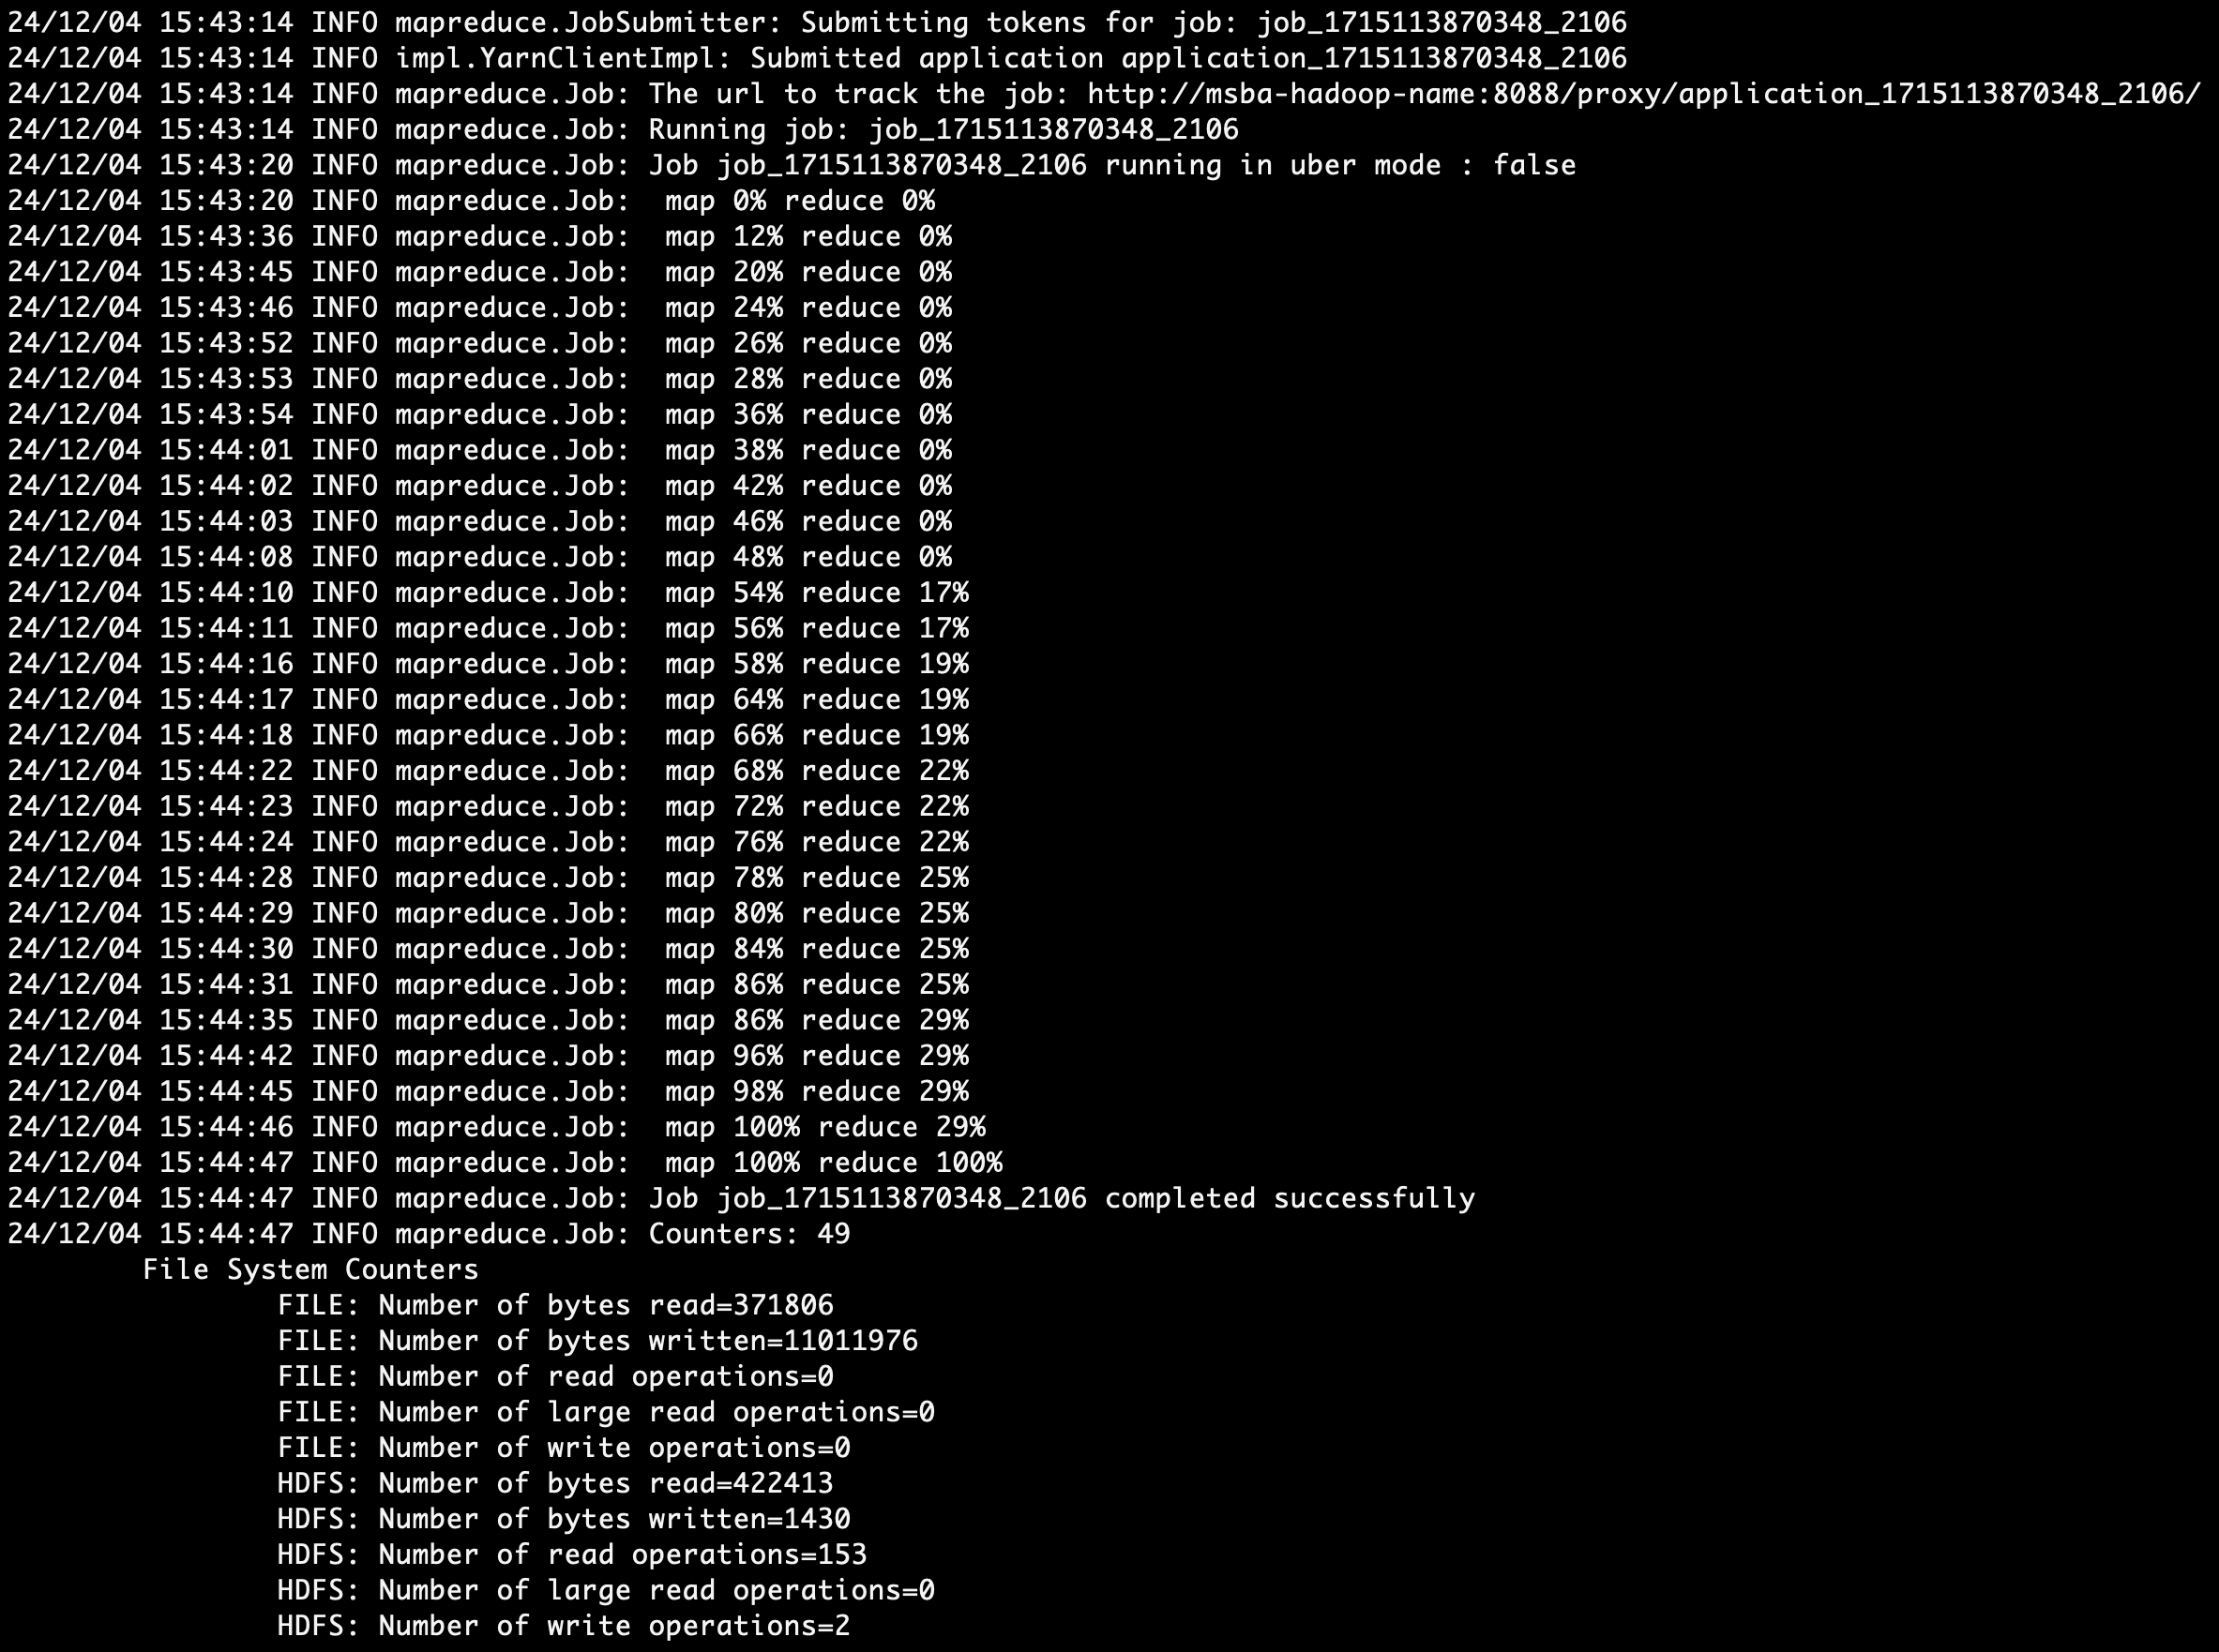

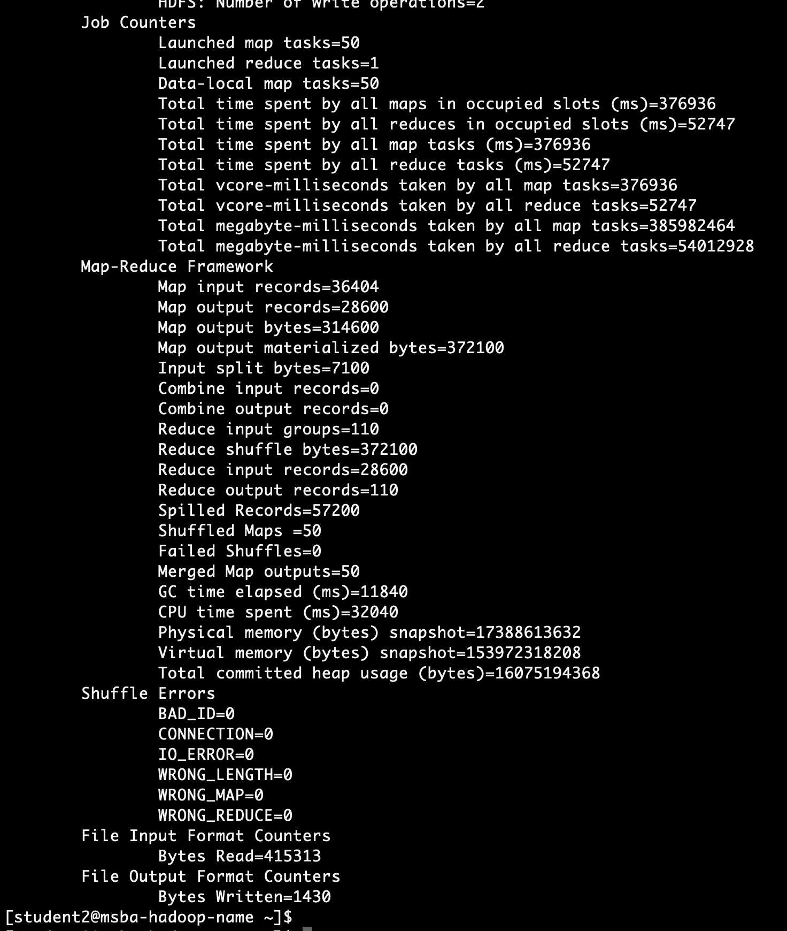

**Listing the contents of Output file directory:**

hdfs dfs -ls /home/2student2/projectoutput/

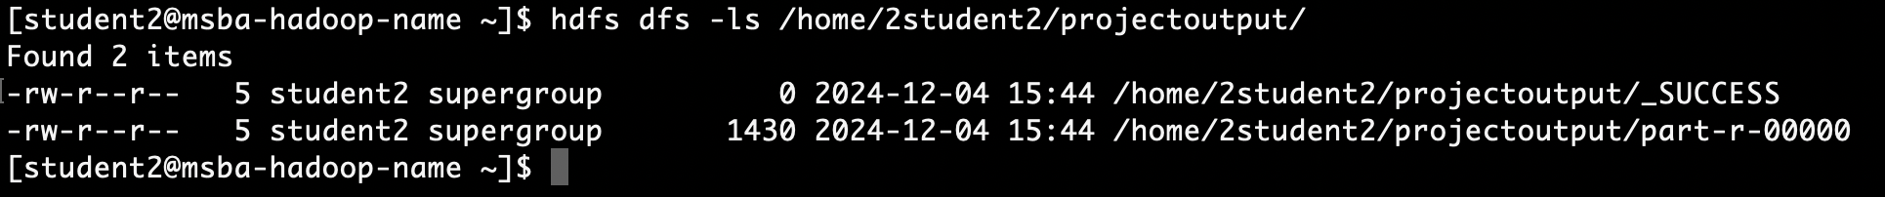

**First few output data:**

hdfs dfs -cat /home/2student2/projectoutput/part-r-00000 | head

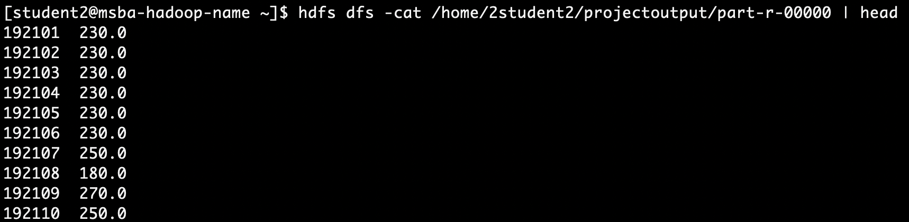

**Last few output data:**

hdfs dfs -cat /home/2student2/projectoutput/part-r-00000 | tail

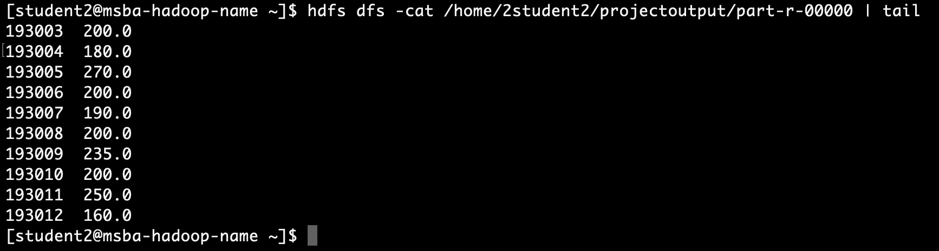

**Part 2:**

The second part is to develop a python application that can be implemented in PySpark to calculate the *range* (the difference between max and min values) *visibility distance* (meters) for *each USAF weather station ID* from NCDC records (note: 999999 indicates missing value, and [01459] indicate good quality value).

**Start a PySpark session in local mode:**

pyspark --master local

Created a python program named **“VisDistance.py”** to calculate the range of visibility distance for each USAF weather station ID

**Run Spark Job:**

spark-submit --master local VisDistance.py /home/2student2/projectinput /home/2student2/Projectsparkoutput

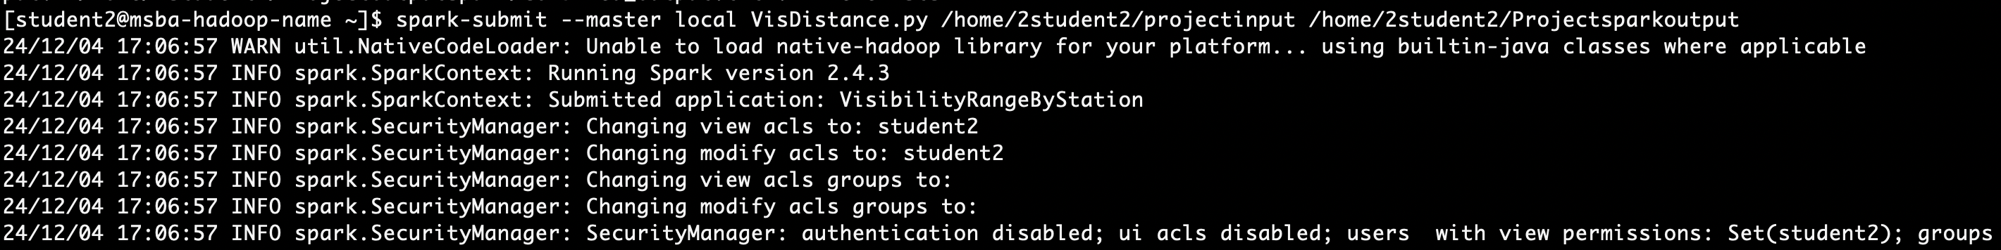

**List Output Files in HDFS Directory:**

hdfs dfs -ls /home/2student2/Projectsparkoutput

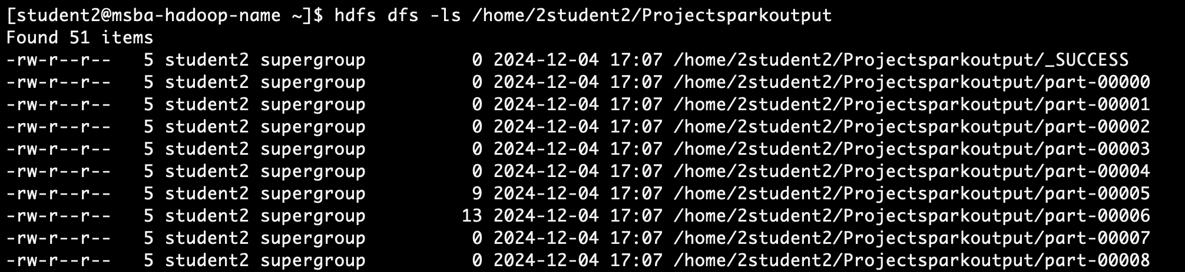

hdfs dfs -cat /home/2student2/Projectsparkoutput/part-* | hdfs dfs -put - /home/2student2/Projectsparkoutput/part2_output.txt

**Display Output File Content:**

hdfs dfs -cat /home/2student2/Projectsparkoutput/part2_output.txt

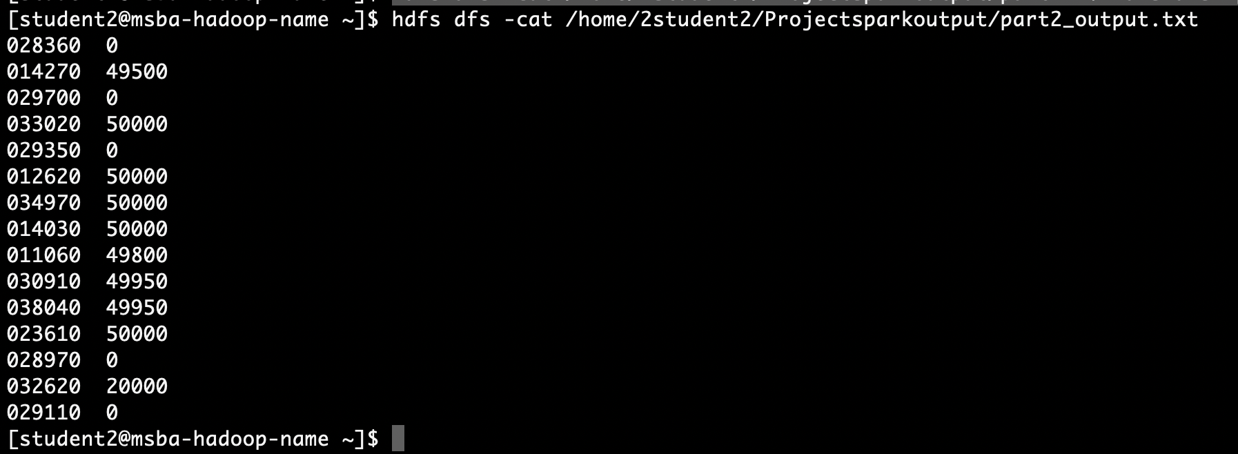

**Part 3:**

Develop a Mapper and Reducer application to retrieve *USAF weather station ID* and *visibility distance (meters)* from NCDC records (note: 999999 indicates missing value, and [01459] indicate good quality value) and then *write* the USAF weather station ID and visibility distance data into *a text file*.

Used **mrjob library**

Created a python program named **“VisDist_MRjob.py”** to retrieve USAF weather station ID and visibility distance

**Execute the python file:**

python VisDist_MRjob.py -r hadoop hdfs:///home/2student2/projectinput --output-dir hdfs:///home/2student2/outputMRjobproject/

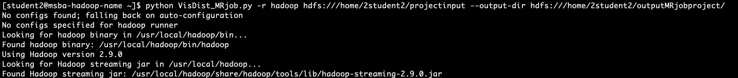

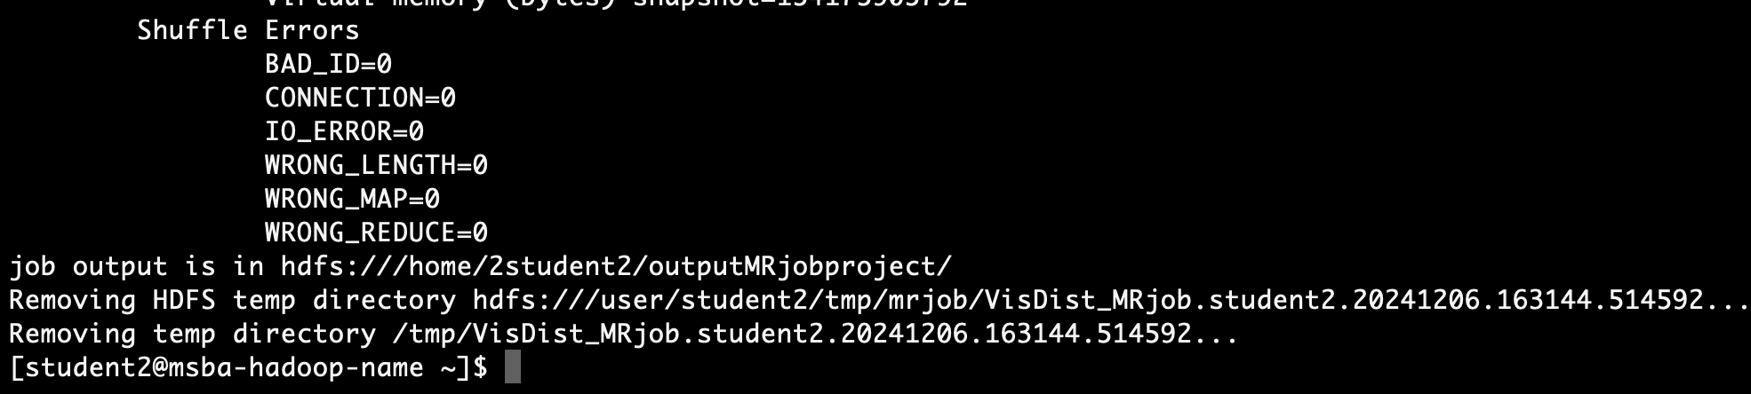

**Listing contents of output directory:**

hdfs dfs -ls /home/2student2/outputMRjobproject/

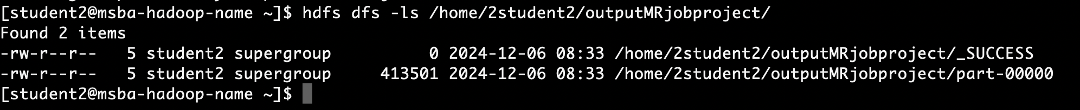

**First few output data:** hdfs dfs -cat /home/2student2/outputMRjobproject/part-00000 | head

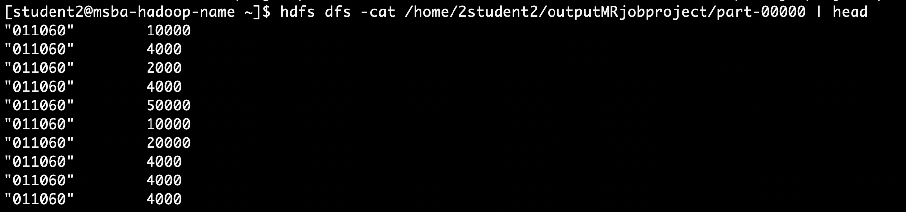

**Last few output data:** hdfs dfs -cat /home/2student2/outputMRjobproject/part-00000 | tail

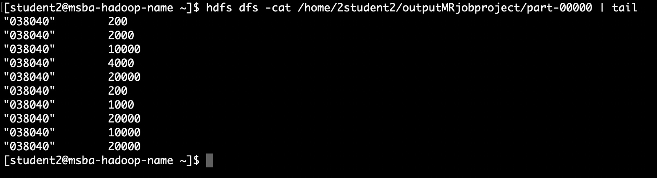

**Write the output to a text file:**



Part 4:

**Load the text file into Pig and get the range of *visibility distance* for each USAF weather station ID.**

pig -x local

records = LOAD 'part3output.txt' USING PigStorage('\t') AS (usaf_id:chararray, visibility:int);

grouped = GROUP records BY usaf_id;

range_data = FOREACH grouped GENERATE

group AS usaf_id,

MAX(records.visibility) - MIN(records.visibility) AS visibility_range;

DUMP range_data;

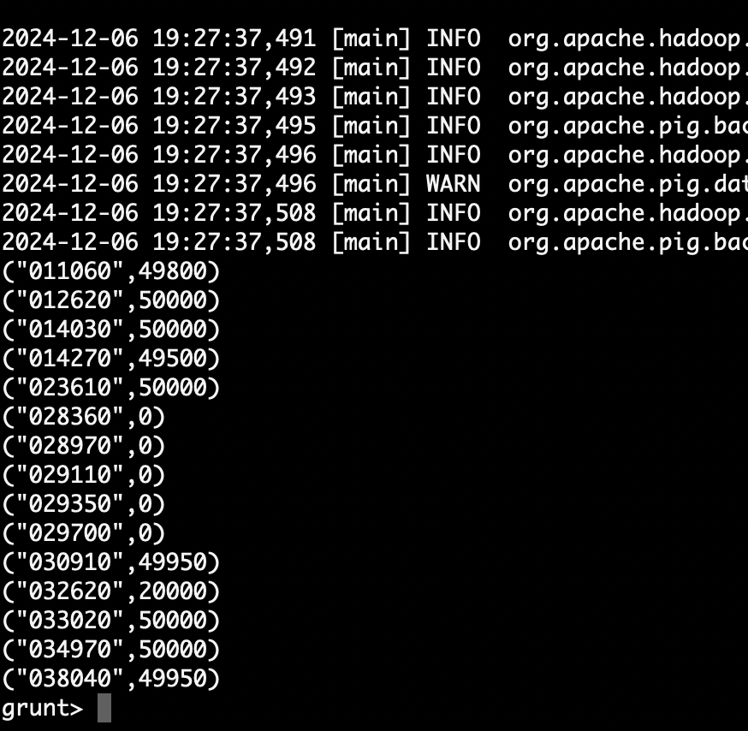

Load the text file into Hive and get the **average** *visibility distance* for each USAF weather station ID.

* ls -l | grep meta
* mv metastore_db metastore_db.old
* schematool -dbType derby -initSchema
* hive

Create the table CREATE TABLE visibility_data ( usaf_id STRING, visibility INT ) ROW FORMAT DELIMITED

FIELDS TERMINATED BY '\t';

LOAD DATA LOCAL INPATH 'part3output.txt' INTO TABLE visibility_data;

SELECT usaf_id, AVG(visibility) AS avg_visibility

FROM visibility_data

GROUP BY usaf_id;

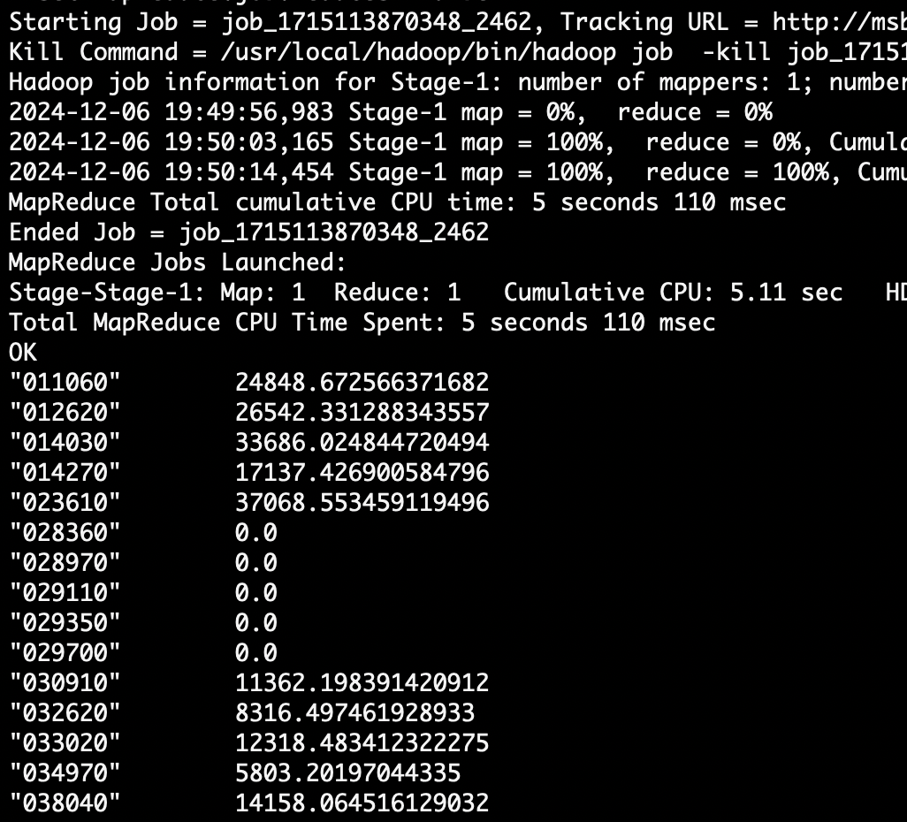

**You need to turn in:**

**1)** Part 1:

a. *if you are using JAVA to develop the Mapper and Reducer applications:* the three java files (mapper, reducer and main);

b. *if you are using Hadoop streaming jar and developing two python programs (mapper python file and reducer python file)*: the two python files (mapper and reducer);

c. *if you are using mrjob library and developing one python program with two functions:* the python file (with the mapper and reducer functions);

2) Part 2: the python program you developed;

3) Part 3: refer to Part 1; and the text file created;

**4)** the commands from converting java files into a Jar file to running the Jar file in Hadoop, or the commands to execute the python files in Hadoop and in Spark, all commands in Pig and Hive;

**5)** the step by step commands and screenshots of solutions from all the parts;

The original dataset for this project is available on Canvas.